EE 564-REPORT OF PROJECT 3

A-Traction Motor Design

Ali GEZER – 1876135

Contents

INTRODUCTION 3

Analytical Section 3

The Main Dimensions 3

Winding Selection 5

Electric and Magnetic Loading 6

the material properties, mechanical frame size 8

the magnetic circuit parameters(flux density calculations at various points: air-gap, teeth, back-core etc, magnetic loading) 8

Electric Circuit(Winding selection, electric loading, fill factor, phase resistance, winding factors (for fundamentalsn and for harmonics)). 8

Rough thermal calculations (cooling method, operating temperature, ways to improve cooling) 8

Efficiency, current, torque characteristics 8

Mass Calculations (structural mass, copper mass, steel mass etc) 8

Compulational Section 8

RMxprt Analysis 8

Torque-Speed Characteristics 9

Current waveforms at rated conditions 9

Efficiency curves 10

Equivalent circuit parameters 10

Effect of skewing etc. 11

CONCLUSION 11

Appendix 11

# INTRODUCTION

In this project, it is asked to design and analyze a traction asynchronous squirrel cage induction motor (with copper rotor-bars) with the following specifications:

* Rated Power Output: 1280 kW
* Line-to-line voltage: 1350 V
* Number of poles: 6
* Rated Speed: 1520 rpm (72 km/h) (driven with 78 Hz inverter)
* Rated Motor Torque: 7843 Nm
* Cooling: Forced Air Cooling
* Insulating Class: 200C
* Train Wheel Diameter: 1210 mm
* Maximum Speed: 140 km/h
* Gear Ratio: 4.82

In the first part; the motor parameters (main dimensions, material properties, mechanical frame size, magnetic circuit parameters, electric circuit parameters, rough thermal calculations, efficiency, current, torque characteristics, mass calculations) are given corresponding to analytical calculations. On the other hand, some computational outputs of the RMxprt tool and the 2D FEA-Maxwell belong to the modeled motor with calculated analytical parameters are given in the second part. At last, not only the comparison of the analytical and computational results, but also general design considerations are investigated.

# Analytical Section

## The Main Dimensions

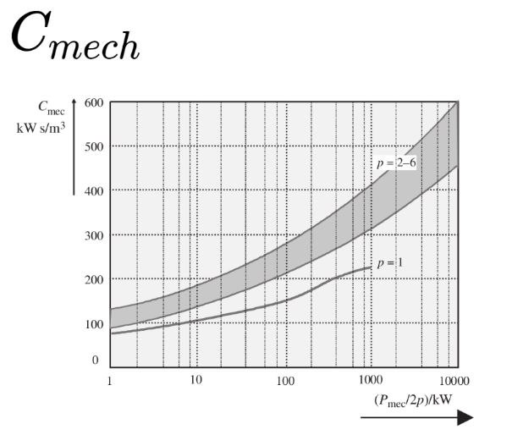Firstly, let’s choose the specific machine constant (Cmech), which depends on the electrical and magnetic loading using the Figure 1.

Considering to be in the interval, Cmech is chosen as;

|  |  |
| --- | --- |
| **Ppole((Pmec/2p)/kW)** | 213,3333333 |
| **Cmech(kW.s/m^3)** | **250** |

Figure 1

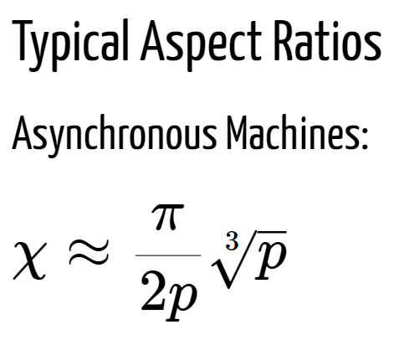Then, using the following formulas, we can calculate stator inner diameter and effective length:

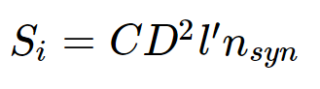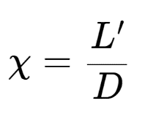

|  |  |
| --- | --- |
| **n-sync(synchronuous rotor speed in Hz)=f/p** | 26 |
| **X-Aspect ratio** | 0,754777275 |
| **D-stator inner diameter(m) = (Pmech/(Cmech.X.nsync))^(1/3)** | **0,638987848** |
| **L'-Effective Length(m)** | **0,482293507** |

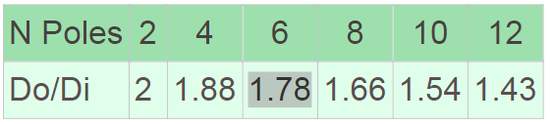After having the inner stator diameter-D, we can calculate the outer stator diameter using the information in Table 1:

Table 1

|  |  |
| --- | --- |
| **Do-stator outer diameter(m) = 1,78*D** | **1,137398369** |

At this point it is important to check whether the tip speed is in the acceptable range or not;

|  |  |
| --- | --- |
| **nmax(rpm)=nrated*(Vmax/Vrated)** | 2955,555556 |
| **Tipspeed(m/s)=2*pi*(D/2)*(nmax/60)** | **98,83485374** |

Since resulting Tip Speed is ~99, it is acceptable (< 100 m/s). Then, we can go on with calculating the airgap length with using the following information;

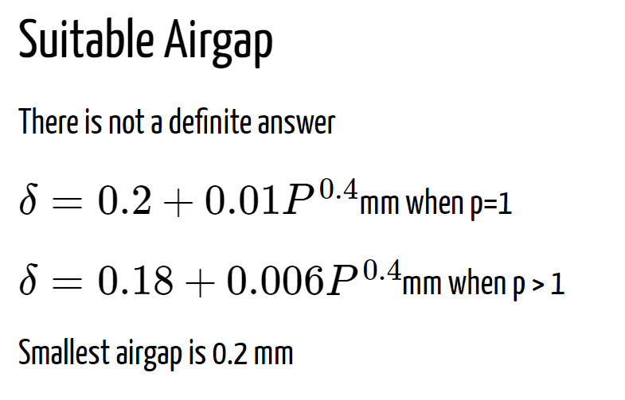

|  |  |
| --- | --- |
| **δ = Lairgap(mm) =0,18+0,006.Pmech^0,4** | 0,284962759 |
| **δ = Lairgap(mm) - smallest airgap** | **2** |

Since calculated airgap is smaller than 2 mm, which is smallest airgap due to the mechanical constraints, the airgap length is determined as 2 mm.

## Winding Selection

In order to select the winding, it is needed to determine the Number of Stator Slots and check the compatibility of slot pitch with the following information;

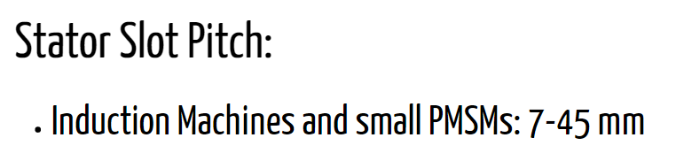

Considering to have integral winding, qs-the number of slots per pole per phase is assumed as 3 and the following calculations are conducted accordingly.

|  |  |
| --- | --- |
| **m - number of phases** | 3 |
| **qs - Number of Slots per pole per phase** | 3 |
| **Qs - Stator Slot Number = 2p * m * qs** | **54** |
| **Stator Slot Pitch (mm) = (2*pi*(D/2))/Qs** | **37,15596005** |

Notice that, Stator Slot Pitch is acceptable (7< 25.76 <45).

|  |  |  |  |  |  |
| --- | --- | --- | --- | --- | --- |
| **n - harmonic number** | 1 | 3 | 5 | 7 | 9 |
| **coil pitch(in elect rad) = (8/9)*pi** | 2,791111111 | 2,791111111 | 2,791111 | 2,791111 | 2,791111 |
| **kp -pitch factor = sin( (n*coil-pitch)/2)** | 0,98468459 | -0,86496168 | 0,640072 | -0,33736 | -0,00637 |
| **a - angle between each coil(in elect rad)**  **= pi/(qs*m)** | 0,348888889 | 0,348888889 | 0,348889 | 0,348889 | 0,348889 |
| **kd-distribution factor**  **= sin(qs*(n*a/2))/(qs*sin(n*a/2))** | 0,95983542 | 0,666973126 | 0,218149 | -0,17683 | -0,33333 |
| **kw - winding factor** | **0,945135147** | **-0,57690619** | **0,139631** | **0,059656** | **0,002124** |

Let’s choose 8/9 under pitched coil-double layer winding. Then, resulting winding factors are calculated corresponding to harmonic number as;

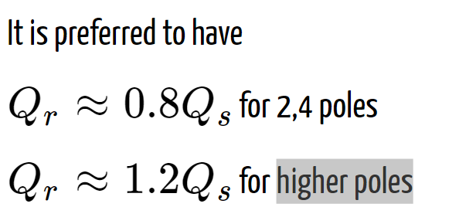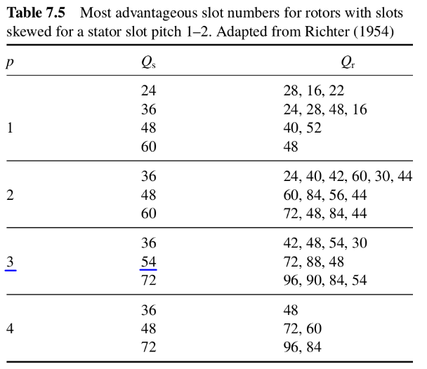Notice that 8/9 under pitched coil eliminates the 9th harmonic as expected.

Also, we can determine the number of rotor slots using the above information and the Table 2. Since, we have 6 poles, we should have Qr >Qs. Also, 72/54~1.33 is closer to 1.2 than 88/54~1.63 .Therefore, Qr is selected as 72.

Table 2

|  |  |
| --- | --- |
| **Qr - Rotor Slot Number (72 or 88)** | **72** |

## Electric and Magnetic Loading

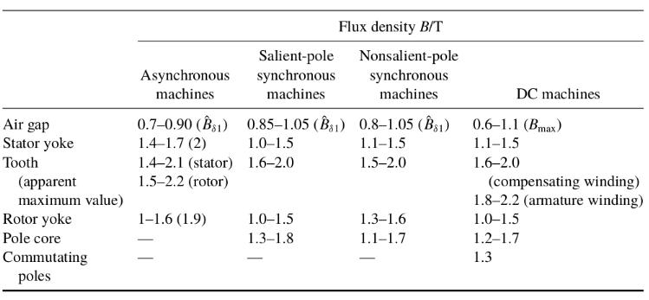In the Table 3, typical flux density values are given. Using this information, we can select an acceptable value for peak airgap flux density = 0.8 T.

Table 3

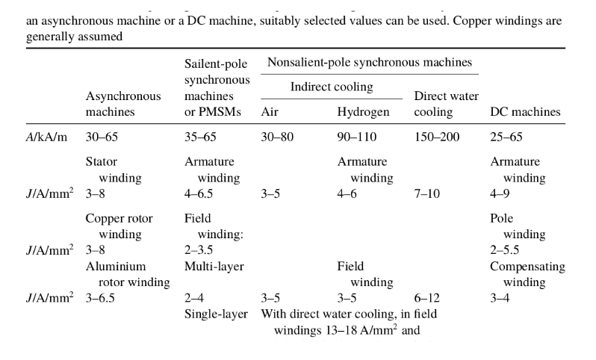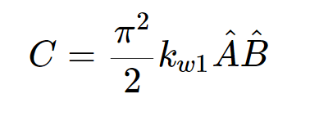Then, using the equation on the right side, we can obtain also electric loading since winding factor and Cmech have already be known.

Table 4

|  |  |
| --- | --- |
| **B^ - peak airgap flux density (T)** | **0,8** |
| **A - linear curr density(kA/m) = Cmech*(2^0,5)/(pi^2*kw1*B^)** | **47,42548812** |

Notice that the current density value is acceptable (30 < 47.43 < 65) as can be seen in the Table 4.

Now, we can determine the winding turns as:

|  |  |  |
| --- | --- | --- |
| **Em - EMF value = 0,98*(V/(3^0,5))** | **935,5022715** |  |
| **w - angular electrical speed = 2*pi*f** | **489,84** |  |
| **Stator Pole Pitch,PP (m) = (Stator Slot Pitch* qs * m)/1000** | **0,33440364** |  |
| **ai -coeff of arithmetic average of the flux density of one pole=2/pi** | 0,636942675 |  |
| **Ns - # of coil t.s in sers in a ph = (2^0.5)*Em/(w*kws*L`*PP*ai*B^)** | 34 | **36** |
| **zq - # of conductors per slot = (2*1*m*Ns)/Qs** | 3,777777778 | **4** |
| **Resulting B^ (T)** | **0,772727599** |  |

Since we have double layer winding, zq should be an even integer number. Therefore, Ns is rounded to an appropriate number (=36), and resulting peak airgap flux density is calculated. Notice that 0.77 T is also a proper value for peak airgap flux density.

Again using Table 3, we can select peak stator teeth flux density = peak rotor teeth flux density = 1.7(T). Using this, we ca determine the stator and rotor teeth width as;

|  |  |
| --- | --- |
| **B^st (T) - peak stator teeth flux density** | 1,7 |
| **kFe - space factor of the iron** | 1 |
| **L - Real Length(m) ~ L`** | 0,482293507 |
| **bds - stator teeth width(mm) = (L`*SP*B^)/(kFe * L * B^st) + 0.1** | **17** |
| **Rotor Slot Pitch,RSP (mm) = (2*pi*(D/2))/Qr** | **27,86697004** |
| **B^rt (T) - peak rotor teeth flux density= B^st (T)** | 1,7 |
| **bdr - rotor teeth width(mm) = (L`*RSP*B^)/(kFe * L * B^rt) + 0.1** | **13** |

Notice that the teeth width values are rounded considering production tolerances.

Before determination of other slot dimensions, we need to find the necessary area in a slot considering the current and the current density. Then, we can determine slot dimensions assuming 95% efficiency and 0.8 pf;

|  |  |
| --- | --- |
| **eff** | 0,95 |
| **pf** | 0,8 |
| **Is (A)- Stator current = (Pmech*1000/3) / ((V/(3.0^0.5))*eff*pf)** | 720,2810376 |
| **Ir (A)- Rotor current = zq*Qs*Is*0.9/(4*Qr)** | 486,1897004 |
| **J (A/mm^2)** | 4 |
| **Acs(mm^2) - Stator conductor area = Is/(4*J)** | 45,01756485 |
| **Acr(mm^2) - Rotor conductor area = Ir/(4*J)** | 121,5474251 |
| **awg-8 current rating (A)** | 75 |
| **A-awg8 (mm^2)** | 8,3 |
| **Nawg8 - Number of needed awg8 = Is/awg-8 current rating** | 10 |
| **Space factor coeff** | 0,7 |
| **Ass (mm^2) - Area of stator slot = A-awg8*Nawg8*zq/Spacefactor** | 474,2857143 |
| **Ars (mm^2) - Area of rotor slot = Acr** | 121,5474251 |
| **Stator slot width,SSW(mm) = SP-bds** | **20,15596005** |
| **Rotor slot width,RSW(mm) = RSP-bdr** | **14,86697004** |
| **Stator slot depth,SSD(mm) = Ass/SSW** | **23,53079253** |
| **Rotor slot depth(mm) = Ars/RSW** | **8,175668934** |

Having all this information, we can determine inner rotor diameter and a more accurate value for Do-outer diameter for stator selecting a proper value for yoke flux densities from the Table 3:

|  |  |
| --- | --- |
| **B^sy (T) - peak stator yoke density** | 1,5 |
| **B^ry (T) - peak rotor yoke density** | 1,2 |
| **App (m^2)- Area per pole = L`*D*pi/(2p)** | 0,161280704 |
| **Flux per pole = App * B^** | 0,124626051 |
| **Do(mm) = ((Fluxperpole/2)/(L`*B^sy))+(D+SSD)** | **748,6529479** |
| **Dir(mm) = (D-RSD)-((Fluxperpole/2)/(L`*B^ry))** | **523,1442949** |

## the material properties, mechanical frame size

## the magnetic circuit parameters(flux density calculations at various points: air-gap, teeth, back-core etc, magnetic loading)

## Electric Circuit(Winding selection, electric loading, fill factor, phase resistance, winding factors (for fundamentalsn and for harmonics)).

## Rough thermal calculations (cooling method, operating temperature, ways to improve cooling)

## Efficiency, current, torque characteristics

## Mass Calculations (structural mass, copper mass, steel mass etc)

# Compulational Section

## RMxprt Analysis

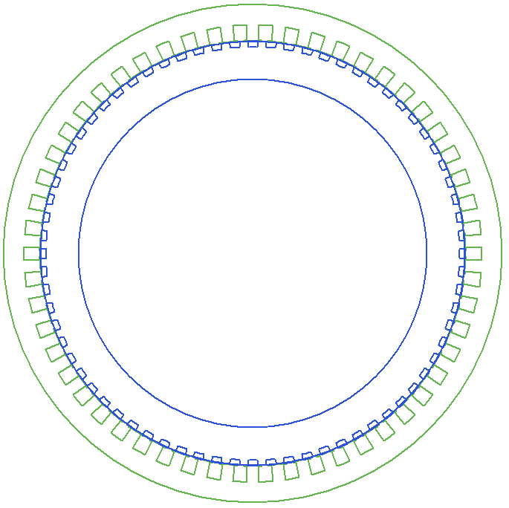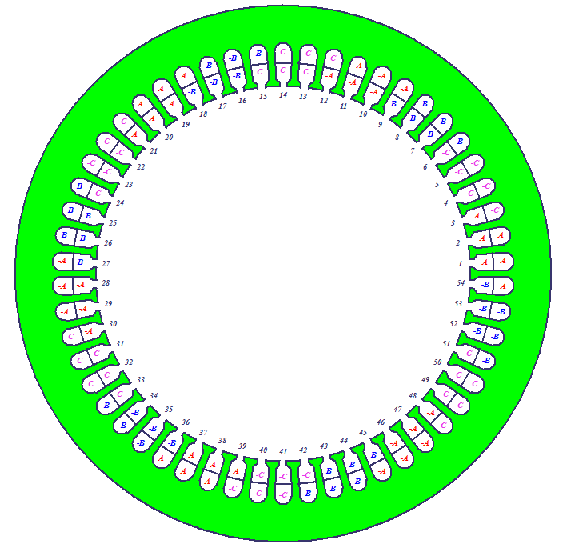 The Design Sheet (Output.pdf) obtained from the RMxprt tool is attached.

Figure 5: Main Machine Model

Figure 4: Winding of the Model

## Torque-Speed Characteristics

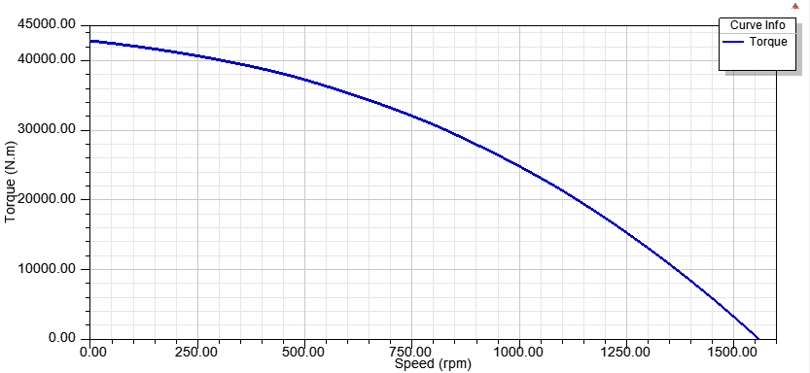

## Current waveforms at rated conditions

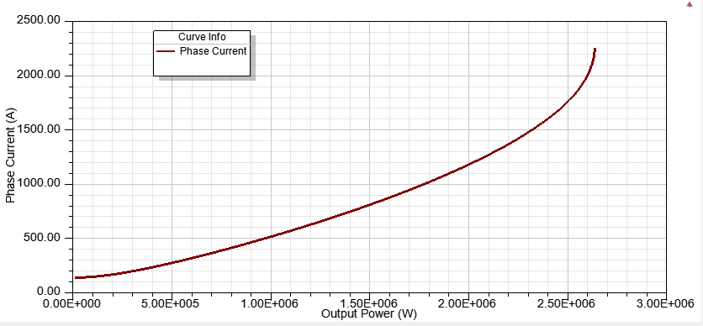

## Efficiency curves

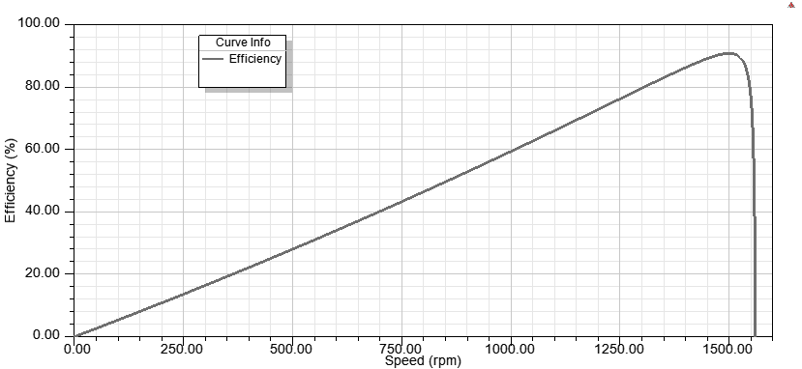

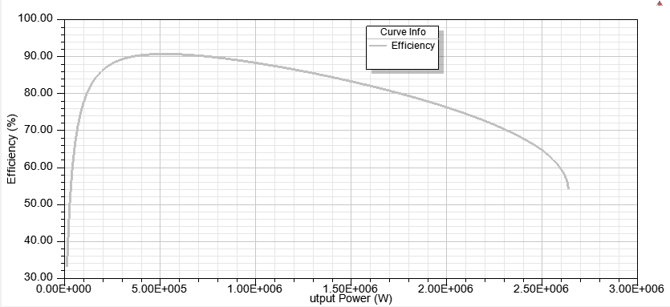

## Equivalent circuit parameters

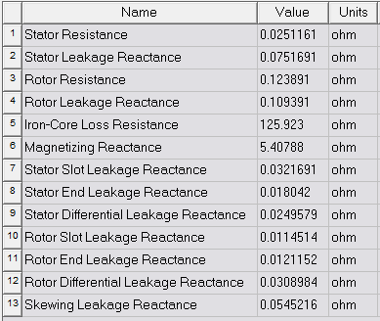

## Effect of skewing etc.

Note that skew width is 2*RSP (rotor slot pitch) = 55.72 mm.

Skewing provides to avoid the cogging phenomenon and harmonics. With a skewed construction of rotor, magnetic locking or strong coupling of the machine may be prevented. Increase on rotor resistance may be considered as another effect of skewing. Thanks to this increase, starting torque of the machine may be improved.

# CONCLUSION

Conc

# Appendix

All analytical calculations can be found in the attached excel file (P3_analytical calculations_vX.xlsx).